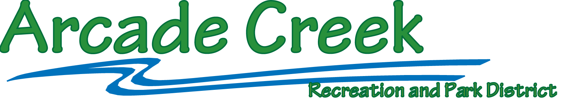

Finance - Budget Committee Meeting
Tuesday January 11, 2021 @ 6 PM
District Office: 4855 Hamilton Street, Sacramento, CA 95841

AGENDA

- Call to Order and perform Roll Call (Treasurer – Amanda Gualderama)

2. Public Comment – this is the opportunity for members of the public to address the Board on any topic within the Board’s jurisdiction NOT listed on the agenda. The Board will take comments only but cannot act upon any item not listed on the Agenda.
Each speaker will be limited to five minutes of time.
The Board will not receive comments relating to District Personnel during this time. These comments must be made in writing to the General Manager and in the case of the General Manager made in writing to the Chairperson of the Board.
Questions about the daily operation of the park district should be directed to the General Manager during normal working hours when possible.
Comments related to a specific item on the agenda will be received by the Board at that time during the meeting.
Members of the public may gain recognition by registering with the Secretary to the Board prior to the start of the meeting or by raising their hand to be recognized by the Chairperson of the Board at the time they wish to speak, and public comment is welcomed.
Although public comments on agenda items are welcomed during each discussion, public comments of a general nature will not be received once the Board Chair has closed the Public Comment period.

3. Business

- Quarters One and Two (July thru December) FY 2021-22 Budget Review

b. ACP Projects Review

4. Adjournment of the meeting.

NOTICE
Where proper or considered necessary, the Board may act on any item listed on the Agenda; including items listed as information items. Public documents relating to any open session item(s) listed on this agenda that are distributed to the members of the Board of Directors less than 72 hours before the meeting is available for public inspection in the District’s Office at 4855 Hamilton Street, Sacramento, CA 95841.
In compliance with the Americans with Disabilities Act, if you have a disability, and you need a related modification or accommodation to take part in this meeting, please contact the Arcade Creek Recreation and Park District office at (916) 482-8377. Requests must be made as early as possible, and at least three full business days (72-hours) before the start of the meeting.
The Agenda is posted on the District’s website (www.acrpd.com), are electronically mailed to residents whom have requested an electronic version and are posted for public inspection on the bulletin board just outside the District Office’s front door. A full hard copy is available at the front desk a minimum of 72 hours in advance.

